1.

public class Example {

public static void main(String[] args){

System.out.println("Welcome to java programming...!");

}

}

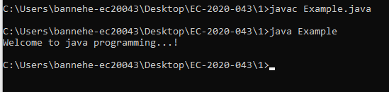

2.

public class GetNumber {

public static void main(String[] args) {

int a = Integer.parseInt(args[0]);

System.out.println("Number: " + a);

}

}

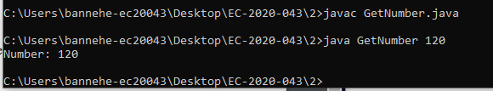

3.

public class Ex3 {

public static void main(String args[]) {

System.out.println("This is my third java program.");

System.out.print("My name is ");

for(int i = 0; args.length > i; i++) {

System.out.print(args[i] + " ");

}

}

}

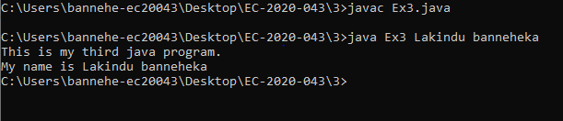

4.

public class Ex4 {

public static void main(String args[]) {

for(int i = 0; args.length > i; i++) {

System.out.print(args[i] + " ");

}

}

}

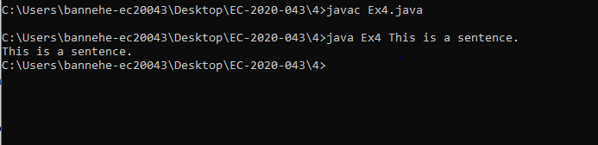

5.

EX1

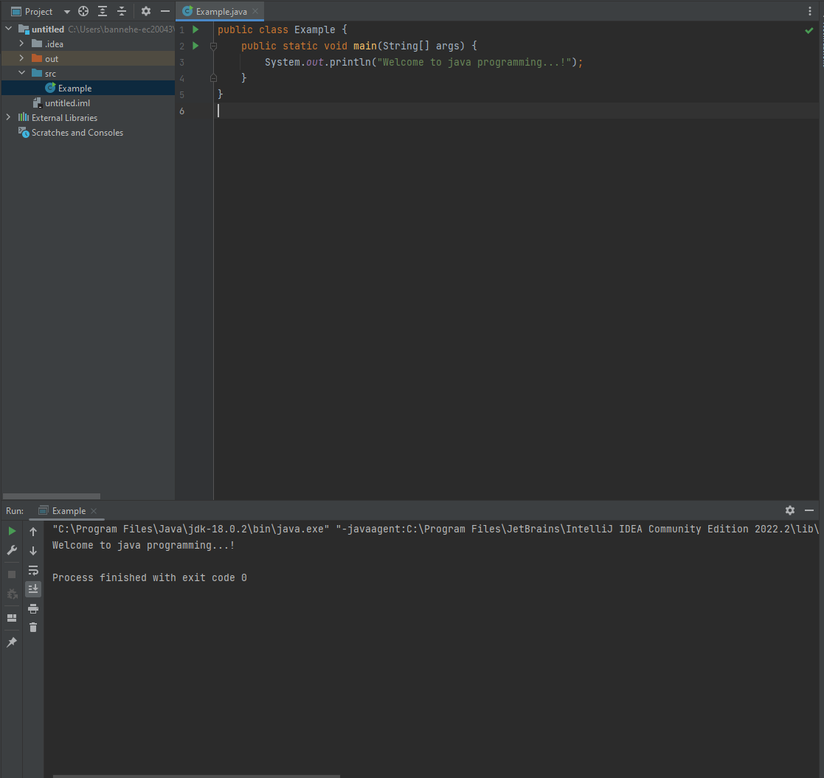

Ex2

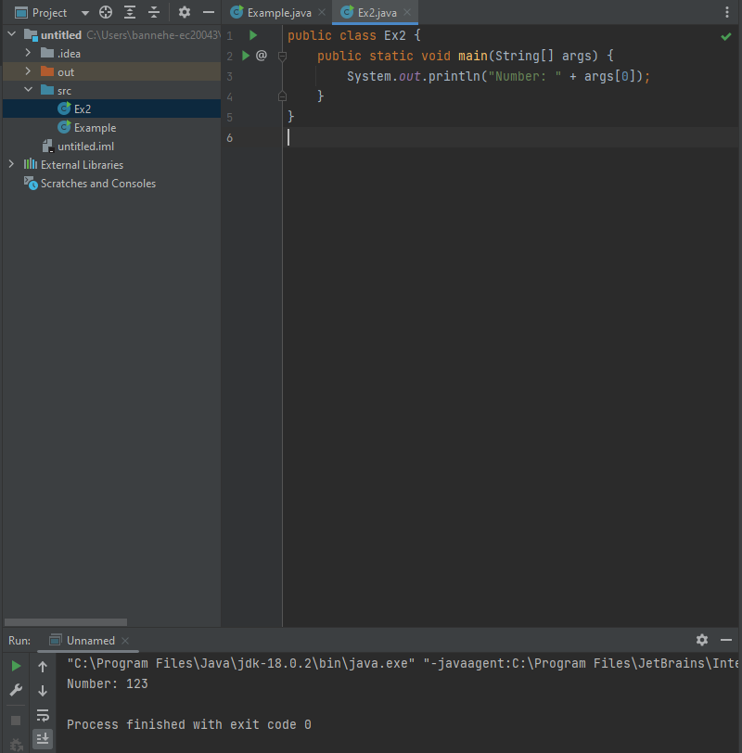

EX3

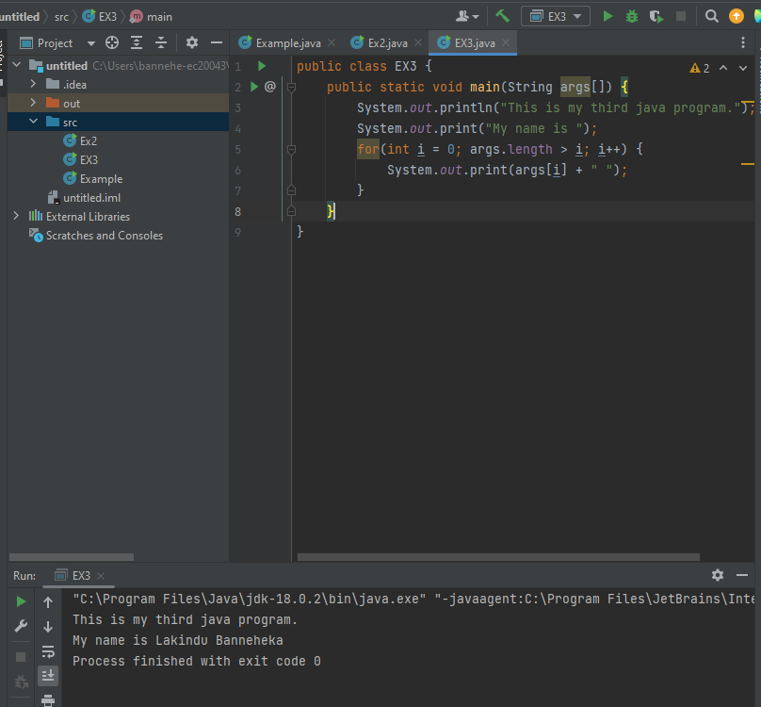

Ex4

